**Source: HEAD acoustics GmbH**

**Title: Report on ATeMPO_SPINE round-robin tests conducted at HEAD acoustics**

**Document for: Information**

**Agenda Item: 10.5**

# Content

1 Content 1

2 Background 2

3 Tests at Head acoustics lab according to the test plan 2

4 Physical test setup for the tests in the sending direction 3

4.1 Loudspeaker setup in room 1 3

4.2 Loudspeaker setup in room 2 4

4.3 Further information 6

5 Equalization results 7

5.1 Hand-held handsfree equalization results (8 speaker method) 7

5.1.1 Room 1 7

5.1.2 Room 2 12

5.2 Desktop handsfree equalization results (8 speaker method) 17

5.2.1 Room 1 17

5.2.2 Room 2 22

5.3 Equalization results for the 4.1 speaker method (ES 202 396-1) 27

5.3.1 Room 1 27

5.3.2 Room 2 27

5.4 Mouth equalization results 28

6 Additional positioning information for the ES 103 224 method 28

7 Test results HHHF 29

7.1 Comparison of Rooms 29

7.1.1 Wideband 29

7.1.2 Narrowband 33

7.2 Comparison of equalization methods 36

7.2.1 Wideband 36

7.2.2 Narrowband 40

7.3 Analyses of the noise spectra reproduced at the reference microphone 43

7.3.1 Simulation & noises acc. to ES 202 396-1 43

7.3.2 Simulation & noises acc. to TS 103 224 46

8 Test results DTHF 50

8.1 Comparison of Rooms 50

8.1.1 Wideband 50

8.1.2 Narrowband 53

8.2 Comparison of equalization methods 56

8.2.1 Wideband 56

8.2.2 Narrowband 57

8.3 Analyses of the noise spectra reproduced at the reference microphone 59

8.3.1 Simulation acc. to ES 202 396-1 59

8.3.2 Simulation acc. to TS 103 224 60

9 Conclusions from the tests 60

10 References 60

# Background

For the 3GPP work item “Acoustic Test methods and Performance Objectives for Speakerphone Performance in Noisy Environments” (ATeMPO_SPINE) a round robin test was conducted.

The following questions should be answered:

1. How good is the reproducibility of the ETSI ES 202 396-1 and ETSI TS 103 224 background noise (BGN) simulation methods?
2. Find out whether the different BGN simulation methods lead to different S-MOS-LQO and N­MOS­LQO results when measuring the same UE. ”

The objective of the present document is to document how the tests following the test plan in [1] were conducted in the HEAD acoustic lab and to report on some observations made.

# Tests at Head acoustics lab according to the test plan

Tests were conducted at the HEAD acoustics premises in Aachen, Germany, during weeks 22 and 23. As described in [2] the basis was to measure S-MOS, N-MOS and G-MOS for the ETSI ES 103 106 quality predictor in various conditions.

Two rooms were available and were used:

|  |  |  |
| --- | --- | --- |
| **Room number** | **C80** | **RT60** |
| Lab 1.1 | 37.1 dB | 125 ms |
| Lab 1.2 | 20.5 dB | 240 ms |

Absorbing materials were introduced in room 2 to reach the C80>20dB as required by TS 103 224 [5].

As described in [1] different background noise methods were used:

* 8-speaker method (ETSI TS 103 224)
* 4.1 loudspeaker method (ETSI ES 202 396-1)
* 4.1 loudspeaker method using the same noise scenarios as in TS 103 224, for HHHF DUT position:

Those methods were used in different setups:

* DUT in front of HATS “hand-held handsfree” (6 noise types plus silence)1
* DUT laying on a table “desktop handsfree” (one noise type plus silence)

Everything was measured in narrowband as well as wideband.

HEAD acoustics ACQUA with the HAE-BGN and 3PASS background noise systems were used. Nubert Loudspeakers were used (nuLine 24, WS-203, nuBox 381) For HAE-BGN a HEAD acoustics HSW 2.1 subwoofer was used. The test sequences were provided by HEAD acoustics. A HEAD acoustics HATS HMS II.3 was used on a torso box.

**Procedure**

The mouth simulator of the HATS was calibrated at MRP using a 1/2-inch pressure-field microphone. The HFRP calibration was performed for the two different measurement distances, 30 and 50 cm. The HATS ears were calibrated.

Additional notes on the equalization of the 4.1 speaker system:

* standard delays were used
  + Front left: 0 ms, Front right: 11 ms
  + Rear left: 17 ms, Rear right: 29 ms

# Physical test setup for the tests in the sending direction

In all of the rooms the HATS height was HRP 120 cm above the floor. The equalization was always done with HATS in place.

## Loudspeaker setup in room 1

**Room size:**

Length: 3.3m

Width: 2.4m

**Speaker height**

Speakers 1-4 (Nubert nuLine 24): top edge 152 cm, lower edge 126 cm.

Speakers 5-8 (Nubert WS-203): top edge 137 cm, lower edge 99 cm.

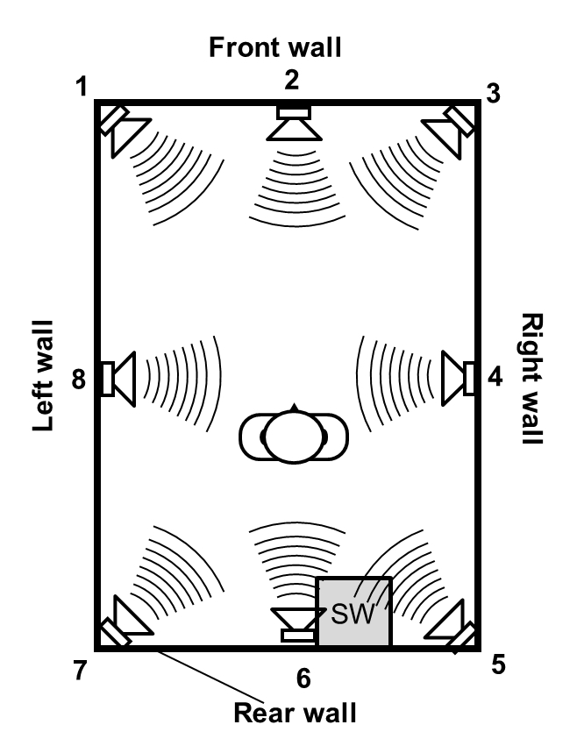

**Figure 1: Speaker placement in room 1**

Loudspeakers 1,3,5,7 were positioned in the corners of the room whereas loudspeakers 2,4 and 8 were positioned in the midway on the edges. Because of the door of the room loudspeaker 6 is shifted slightly to the right. The subwoofer was positioned 90 cm from the right wall.

As the DUT was located in the mid of the room and the distance between DUT and HATS’ MRP had to be 30 cm the HATS was located 135 cm from the rear wall and centered between the side walls.

## Loudspeaker setup in room 2

**Room size:**

Length: 3.3m

Width: 2.4m

**Speaker height**

Speakers 1-4 (Nubert nuBox381): top edge 150 cm, lower edge 112 cm.

Speakers 5-8 (Nubert nuBox381): top edge 104 cm, lower edge 66 cm.

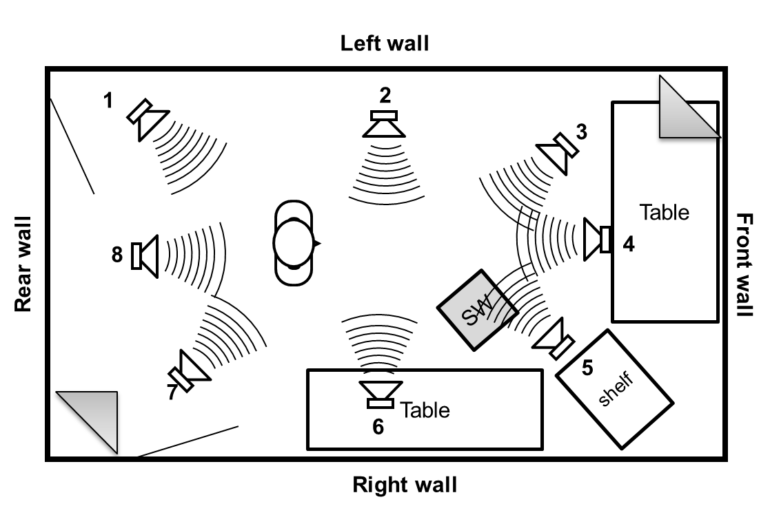

**Figure 2: Speaker placement in room 2 which was acoustically treated, triangles in corner show positions of edge absorbers**

|  |  |  |  |  |
| --- | --- | --- | --- | --- |
| **Loudspeaker** | **Left wall** | **Front wall** | **Right wall** | **Rear wall** |
| **1** | 30 cm |  |  | 130 cm |
| **2** | 30 cm | 260 cm |  |  |
| **3** | 60 cm | 150 cm |  |  |
| **4** | 120 cm | 140 cm |  |  |
| **5** |  | 180 cm | 110 cm |  |
| **6** |  | 260 cm | 80 cm |  |
| **7** |  |  | 80 cm | 80 cm |
| **8** | 130 cm |  |  | 110 cm |
| **Subwoofer (SW)** |  | 200 cm | 150 cm |  |
| **HATS** | 115 cm |  |  | 230 cm |

**Table 1. Loudspeaker positions in room 2.**

As already described some absorbing material had to be brought into room 2 to reach a sufficient C80 value of >20 as required in [3]. In Figure 2 the positions of the edge absorbers used are shown.

## Further information

**Equalization after ES 202 396-1:**

For the equalization after ES 202 396-1 only the speakers in the corners were used hence 1,3,5,7 for room 1 and 3,5,7,1 for room 2.

**Desktop hands-free case**

In the DTHF case a 1m x 1m table was introduced with the DUT located on the table, 40 cm from the lower edge. In this case the HATS had to be moved 10 cm further back. The same procedure was followed in both rooms.

# Equalization results

## Hand-held handsfree equalization results (8 speaker method)

### Room 1

**Report for Filter Validation "Filter Validation"**

**Settings of Setup "Round Robin Handsfree** "

|  |  |
| --- | --- |
| Comment | Round Robin Handsfree |
| Lower Frequency bound | 50 Hz |
| Higher Frequency bound | 20000 Hz |
| Setup Creation | 02.06.2015 09:51:41 |
| Last Equalization | 02.06.2015 09:59:19 |

Measured impulse responses

|  |  |  |  |
| --- | --- | --- | --- |
| Calibration Position |  | Fine tuning position |  |
|  |  |  |  |
|  |  |  |  |
|  |  |  |  |
|  |  |  |  |

Impulse responses of filters

|  |  |  |  |
| --- | --- | --- | --- |
|  |  |  |  |
|  |  |  |  |

Filter Validation

|  |  |
| --- | --- |
| Name | Filter Validation |
| Comment |  |
| Date and Time of Check | 02.06.2015 10:02:34 |
| Overall Equalization Result | OK |

***Used microphone calibration not found!***

Level Deviations

|  |  |  |  |  |  |  |  |  |
| --- | --- | --- | --- | --- | --- | --- | --- | --- |
|  | Mic 1 | Mic 2 | Mic 3 | Mic 4 | Mic 5 | Mic 6 | Mic 7 | Mic 8 |
| Calibration pos | -0,03 | 0,01 | 0,17 | -0,13 | 0,05 | 0,11 | 0,31 | -0,46 |
| Fine tuning pos | 0,07 | 0,18 | 0,21 | -0,03 | 0,15 | 0,16 | 0,42 | -0,56 |

Results of single accuracy checks

|  |  |  |  |  |
| --- | --- | --- | --- | --- |
| Frequency Response I | 50 Hz | 10000 Hz | OK | Calibration position |
| Frequency Response II | 10000 Hz | 16000 Hz | OK | Calibration position |
| Average Frequency Response | 50 Hz | 20000 Hz | OK | Calibration position |
| Mag. of Complex Coherence | 100 Hz | 1000 Hz | OK | Calibration position |
| Phase of Complex Coherence I | 100 Hz | 1000 Hz | OK | Calibration position |
| Phase of Complex Coherence II | 1000 Hz | 1500 Hz | OK | Calibration position |
| Frequency Response I | 50 Hz | 10000 Hz | OK | Fine tuning position |
| Frequency Response II | 10000 Hz | 16000 Hz | OK | Fine tuning position |
| Average Frequency Response | 50 Hz | 20000 Hz | OK | Fine tuning position |
| Mag. of Complex Coherence | 100 Hz | 1000 Hz | OK | Fine tuning position |
| Phase of Complex Coherence I | 100 Hz | 1000 Hz | OK | Fine tuning position |
| Phase of Complex Coherence II | 1000 Hz | 1500 Hz | OK | Fine tuning position |

Diagrams of validation results

|  |  |
| --- | --- |
| Calibration Position | Fine tuning position |
| Frequency Response I | 50 Hz to 10000 Hz |
|  |  |
| Frequency Response II | 10000 Hz to 16000 Hz |
|  |  |
| Average Frequency Response | 50 Hz to 20000 Hz |
|  |  |
| Mag. of Complex Coherence | 100 Hz to 1000 Hz |
|  |  |
| Phase of Complex Coherence I | 100 Hz to 1000 Hz |
|  |  |
| Phase of Complex Coherence II | 1000 Hz to 1500 Hz |
|  |  |

### Room 2

**Report for Filter Validation "Filter Validation"**

**Settings of Setup " Reverberant HHHF** "

|  |  |
| --- | --- |
| Comment | Reverberant HHHF |
| Lower Frequency bound | 50 Hz |
| Higher Frequency bound | 20000 Hz |
| Setup Creation | 31.05.2015 10:18:13 |
| Last Equalization | 31.05.2015 10:26:31 |

Measured impulse responses

|  |  |  |  |
| --- | --- | --- | --- |
| Calibration Position |  | Fine tuning position |  |
|  |  |  |  |
|  |  |  |  |
|  |  |  |  |
|  |  |  |  |

Impulse responses of filters

|  |  |  |  |
| --- | --- | --- | --- |
|  |  |  |  |
|  |  |  |  |

Filter Validation

|  |  |
| --- | --- |
| Name | Filter Validation |
| Comment |  |
| Date and Time of Check | 31.05.2015 10:30:14 |
| Overall Equalization Result | OK |

***Used microphone calibration not found!***

Level Deviations

|  |  |  |  |  |  |  |  |  |
| --- | --- | --- | --- | --- | --- | --- | --- | --- |
|  | Mic 1 | Mic 2 | Mic 3 | Mic 4 | Mic 5 | Mic 6 | Mic 7 | Mic 8 |
| Calibration pos | 0,24 | -0,05 | 0,02 | -0,14 | -0,03 | 0,04 | 0,03 | -0,36 |
| Fine tuning pos | 0,33 | -0,07 | -0,08 | -0,29 | -0,09 | 0,04 | -0,09 | -0,36 |

Results of single accuracy checks

|  |  |  |  |  |
| --- | --- | --- | --- | --- |
| Frequency Response I | 50 Hz | 10000 Hz | OK | Calibration position |
| Frequency Response II | 10000 Hz | 16000 Hz | OK | Calibration position |
| Average Frequency Response | 50 Hz | 20000 Hz | OK | Calibration position |
| Mag. of Complex Coherence | 100 Hz | 1000 Hz | OK | Calibration position |
| Phase of Complex Coherence I | 100 Hz | 1000 Hz | OK | Calibration position |
| Phase of Complex Coherence II | 1000 Hz | 1500 Hz | OK | Calibration position |
| Frequency Response I | 50 Hz | 10000 Hz | OK | Fine tuning position |
| Frequency Response II | 10000 Hz | 16000 Hz | OK | Fine tuning position |
| Average Frequency Response | 50 Hz | 20000 Hz | OK | Fine tuning position |
| Mag. of Complex Coherence | 100 Hz | 1000 Hz | OK | Fine tuning position |
| Phase of Complex Coherence I | 100 Hz | 1000 Hz | OK | Fine tuning position |
| Phase of Complex Coherence II | 1000 Hz | 1500 Hz | OK | Fine tuning position |

Diagrams of validation results

|  |  |
| --- | --- |
| Calibration Position | Fine tuning position |
| Frequency Response I | 50 Hz to 10000 Hz |
|  |  |
| Frequency Response II | 10000 Hz to 16000 Hz |
|  |  |
| Average Frequency Response | 50 Hz to 20000 Hz |
|  |  |
| Mag. of Complex Coherence | 100 Hz to 1000 Hz |
|  |  |
| Phase of Complex Coherence I | 100 Hz to 1000 Hz |
|  |  |
| Phase of Complex Coherence II | 1000 Hz to 1500 Hz |
|  |  |

## Desktop handsfree equalization results (8 speaker method)

### Room 1

**Report for Filter Validation "Filter Validation"**

**Settings of Setup "Round** Robin Desktop"

|  |  |
| --- | --- |
| Comment | Round Robin Desktop |
| Lower Frequency bound | 50 Hz |
| Higher Frequency bound | 20000 Hz |
| Setup Creation | 28.05.2015 16:52:35 |
| Last Equalization | 01.06.2015 14:54:00 |

Measured impulse responses

|  |  |  |  |
| --- | --- | --- | --- |
| Calibration Position |  | Fine tuning position |  |
|  |  |  |  |
|  |  |  |  |
|  |  |  |  |
|  |  |  |  |

Impulse responses of filters

|  |  |  |  |
| --- | --- | --- | --- |
|  |  |  |  |
|  |  |  |  |

Filter Validation

|  |  |
| --- | --- |
| Name | Filter Validation |
| Comment |  |
| Date and Time of Check | 01.06.2015 14:54:52 |
| Overall Equalization Result | OK |

***Used microphone calibration not found!***

Level Deviations

|  |  |  |  |  |  |  |  |  |
| --- | --- | --- | --- | --- | --- | --- | --- | --- |
|  | Mic 1 | Mic 2 | Mic 3 | Mic 4 | Mic 5 | Mic 6 | Mic 7 | Mic 8 |
| Calibration pos | -0,18 | 0,06 | 0,08 | 0,08 | 0,03 | 0,06 | 0,20 | -0,65 |
| Fine tuning pos | -0,14 | 0,17 | -0,06 | 0,04 | -0,15 | 0,17 | 0,24 | -0,51 |

Results of single accuracy checks

|  |  |  |  |  |
| --- | --- | --- | --- | --- |
| Frequency Response I | 50 Hz | 10000 Hz | OK | Calibration position |
| Frequency Response II | 10000 Hz | 16000 Hz | OK | Calibration position |
| Average Frequency Response | 50 Hz | 20000 Hz | OK | Calibration position |
| Mag. of Complex Coherence | 100 Hz | 1000 Hz | OK | Calibration position |
| Phase of Complex Coherence I | 100 Hz | 1000 Hz | OK | Calibration position |
| Phase of Complex Coherence II | 1000 Hz | 1500 Hz | OK | Calibration position |
| Frequency Response I | 50 Hz | 10000 Hz | OK | Fine tuning position |
| Frequency Response II | 10000 Hz | 16000 Hz | OK | Fine tuning position |
| Average Frequency Response | 50 Hz | 20000 Hz | OK | Fine tuning position |
| Mag. of Complex Coherence | 100 Hz | 1000 Hz | OK | Fine tuning position |
| Phase of Complex Coherence I | 100 Hz | 1000 Hz | OK | Fine tuning position |
| Phase of Complex Coherence II | 1000 Hz | 1500 Hz | OK | Fine tuning position |

Diagrams of validation results

|  |  |
| --- | --- |
| Calibration Position | Fine tuning position |
| Frequency Response I | 50 Hz to 10000 Hz |
|  |  |
| Frequency Response II | 10000 Hz to 16000 Hz |
|  |  |
| Average Frequency Response | 50 Hz to 20000 Hz |
|  |  |
| Mag. of Complex Coherence | 100 Hz to 1000 Hz |
|  |  |
| Phase of Complex Coherence I | 100 Hz to 1000 Hz |
|  |  |
| Phase of Complex Coherence II | 1000 Hz to 1500 Hz |
|  |  |

### Room 2

**Report for Filter Validation "Filter Validation"**

**Settings of Setup " Reverberant DTHF** "

|  |  |
| --- | --- |
| Comment | Reverberant DTHF |
| Lower Frequency bound | 50 Hz |
| Higher Frequency bound | 20000 Hz |
| Setup Creation | 01.06.2015 19:37:47 |
| Last Equalization | 01.06.2015 19:46:18 |

Measured impulse responses

|  |  |  |  |
| --- | --- | --- | --- |
| Calibration Position |  | Fine tuning position |  |
|  |  |  |  |
|  |  |  |  |
|  |  |  |  |
|  |  |  |  |

Impulse responses of filters

|  |  |  |  |
| --- | --- | --- | --- |
|  |  |  |  |
|  |  |  |  |

Filter Validation

|  |  |
| --- | --- |
| Name | Filter Validation |
| Comment |  |
| Date and Time of Check | 01.06.2015 19:48:41 |
| Overall Equalization Result | OK |

***Used microphone calibration not found!***

Level Deviations

|  |  |  |  |  |  |  |  |  |
| --- | --- | --- | --- | --- | --- | --- | --- | --- |
|  | Mic 1 | Mic 2 | Mic 3 | Mic 4 | Mic 5 | Mic 6 | Mic 7 | Mic 8 |
| Calibration pos | -0,18 | 0,00 | 0,04 | -0,09 | -0,09 | 0,01 | 0,15 | -0,68 |
| Fine tuning pos | -0,19 | 0,10 | -0,14 | -0,14 | -0,26 | -0,08 | 0,24 | -0,71 |

Results of single accuracy checks

|  |  |  |  |  |
| --- | --- | --- | --- | --- |
| Frequency Response I | 50 Hz | 10000 Hz | OK | Calibration position |
| Frequency Response II | 10000 Hz | 16000 Hz | OK | Calibration position |
| Average Frequency Response | 50 Hz | 20000 Hz | OK | Calibration position |
| Mag. of Complex Coherence | 100 Hz | 1000 Hz | OK | Calibration position |
| Phase of Complex Coherence I | 100 Hz | 1000 Hz | OK | Calibration position |
| Phase of Complex Coherence II | 1000 Hz | 1500 Hz | OK | Calibration position |
| Frequency Response I | 50 Hz | 10000 Hz | OK | Fine tuning position |
| Frequency Response II | 10000 Hz | 16000 Hz | OK | Fine tuning position |
| Average Frequency Response | 50 Hz | 20000 Hz | OK | Fine tuning position |
| Mag. of Complex Coherence | 100 Hz | 1000 Hz | OK | Fine tuning position |
| Phase of Complex Coherence I | 100 Hz | 1000 Hz | OK | Fine tuning position |
| Phase of Complex Coherence II | 1000 Hz | 1500 Hz | OK | Fine tuning position |

Diagrams of validation results

|  |  |
| --- | --- |
| Calibration Position | Fine tuning position |
| Frequency Response I | 50 Hz to 10000 Hz |
|  |  |
| Frequency Response II | 10000 Hz to 16000 Hz |
|  |  |
| Average Frequency Response | 50 Hz to 20000 Hz |
|  |  |
| Mag. of Complex Coherence | 100 Hz to 1000 Hz |
|  |  |
| Phase of Complex Coherence I | 100 Hz to 1000 Hz |
|  |  |
| Phase of Complex Coherence II | 1000 Hz to 1500 Hz |
|  |  |

## Equalization results for the 4.1 speaker method (ES 202 396-1)

### Room 1

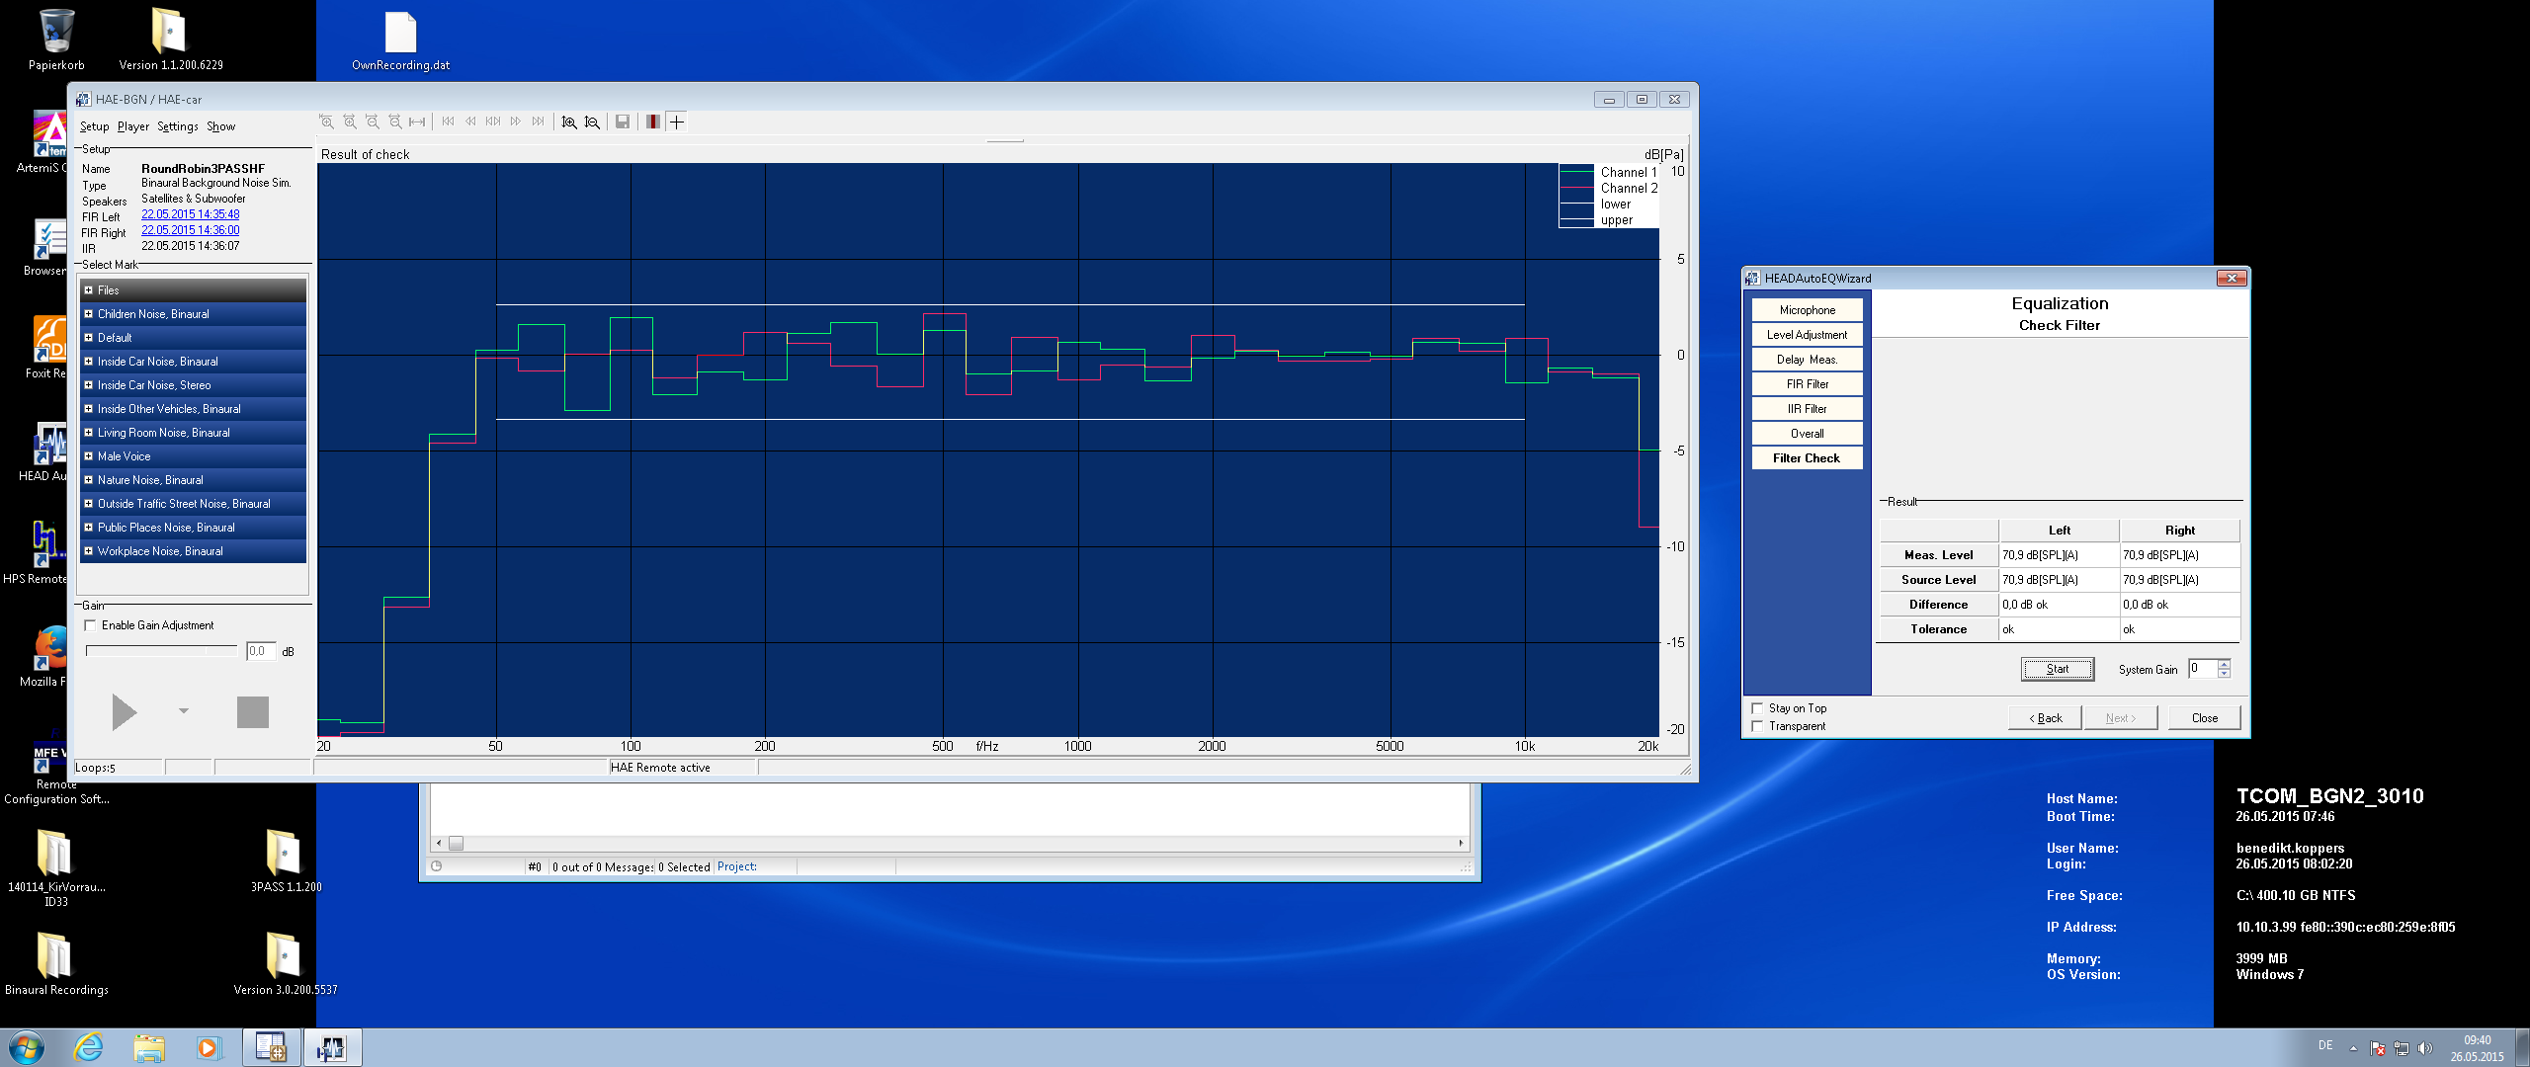

**Figure 3: Equalization result for the 4.1 speaker method described in ES 202 396-1 in room 1**

### Room 2

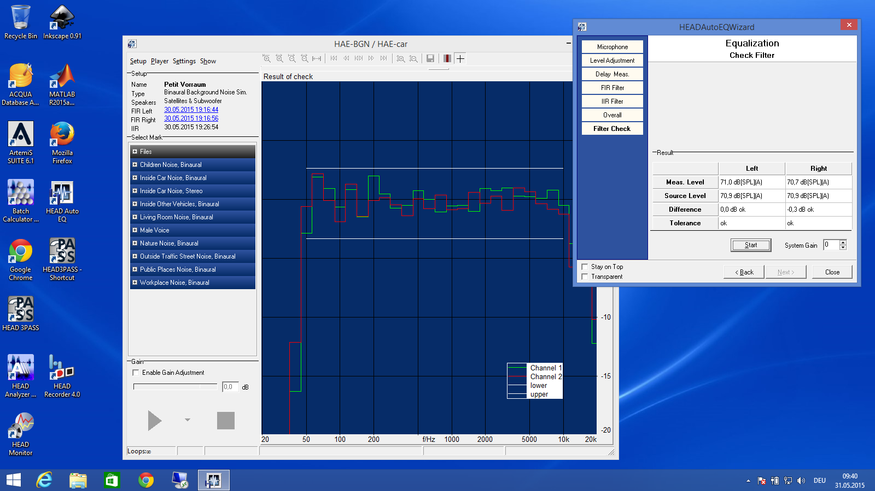

**Figure 4: Equalization result for the 4.1 speaker method described in ES 202 396-1 in room 2**

## Mouth equalization results

The frequency range for which the mouth was equalized was 50 Hz to 14000 Hz.



**Figure 5: Mouth equalization result**

# Additional positioning information for the ES 103 224 method

The positioning was made according to the testing procedure documented in [3].

# Test results HHHF

## Comparison of Rooms

The following diagrams compare the MOS-values measured in the two different rooms by plotting the measured MOS-value of room 1 on the x-axis versus the measured MOS-value of room 2 on the y-axis. As the N-MOS value is the value which is mostly affected by different background noises this value is paid most attention.

### Wideband

**No background noise**

The analysis without any background noise simulation present basically shows the variance to be expected between the different rooms. This variance may be influenced by:

* Calibration differences
* Setup differences
* Room differences
* Time variant behavior of the device under test

**It seems that these parameters may have impact on the results in a similar range than the experiments including the background noise simulation. The RMSE ranges from 0.16 to 0.23.**

|  |  |
| --- | --- |
|  |  |
|  | |

Figure 6: Correlation between MOS results from Lab 1.1 and Lab 2.1 (HHHF, Wideband)

**Simulation & noises acc. to ES 202 396-1**

The results shown in this section are based on using the ES 202 396-1 simulation as well as the background noises from this standard. The following observations can be made:

* The RMSE ranges from 0.08 to 0.18.
* **While for G-MOS and S-MOS no big offset can be observed the N-MOS values in room 2 are better to up to 0.3 then room 1.**

|  |  |
| --- | --- |
|  |  |
|  | |

Figure 7: Correlation between MOS results from Lab 1.1 and Lab 2.1 (HHHF, Wideband)

**Simulation acc. to ES 202 396-1 and noises from TS 103 224**

The results shown in this section are based on using the ES 202 396-1 simulation but using the binaurally recorded background noises from TS 103 224. The following observations can be made:

* RMSE ranges from 0.06 to 0.16
* The S-MOS values line up quite well.
* **The N-MOS values show some scattering which results in an RMSE of 0.16**

|  |  |
| --- | --- |
|  |  |
|  | |

Figure 8: Correlation between MOS results from Lab 1.1 and Lab 2.1 (HHHF, Wideband)

**Simulation & noises acc. to TS 103 224**

The results shown in this section are based on using the TS 103 224 simulation as well as the background noises from this standard. For this setup the following observations can be made:

* RMSE ranges from 0.06 to 0.09
* The G-MOS lines up quite well
* The N-MOS has the lowest RMSE-value compared to the other simulation methods of about 0.09

|  |  |
| --- | --- |
|  |  |
|  | |

Figure 9: Correlation between MOS results from Lab 1.1 and Lab 2.1 (HHHF, Wideband)

### Narrowband

**No background noise**

The analysis without any background noise simulation present basically shows the variance to be expected between the different rooms.

The reasons for the differences were already described in 7.1.1.

**The RMSE ranges from 0.16 to 0.20.**

|  |  |
| --- | --- |
|  |  |
|  | |

Figure 10: Correlation between MOS results from Lab 1.1 and Lab 2.1 (HHHF, Narrowband)

**Simulation & noises acc. to ES 202 396-1**

The results shown in this section are based on using the ES 202 396-1 Simulation as well as the background noises from this standard. The following observations can be made:

* RMSE ranges from 0.10 to 0.25
* Rather high RMSE for N-MOS of about 0.25

|  |  |
| --- | --- |
|  |  |
|  | |

Figure 11: Correlation between MOS results from Lab 1.1 and Lab 2.1 (HHHF, Narrowband)

**Simulation acc. to ES 202 396-1 and noises from TS 103 224**

The results shown in this section are based on using the ES 2002 396-1 Simulation but using the binaurally recorded background noises from TS 103 224. The following observations can be made:

* RMSE ranges from 0.09 to 0.19
* Also a rather high RMSE of 0.19 can be observed for the N-MOS results

|  |  |
| --- | --- |
|  |  |
|  | |

Figure 12: Correlation between MOS results from Lab 1.1 and Lab 2.1 (HHHF, Narrowband)

**Simulation & noises acc. to TS 103 224**

The results shown in this section are based on using the TS 103 224 Simulation as well as the background noises from this standard. For this setup the following observations can be made:

* RMSE ranges from 0.07 to 0.13.
* Compared to the other methods the RMSE of the N-MOS results is quite low at 0.07.

|  |  |
| --- | --- |
|  |  |
|  | |

Figure 13: Correlation between MOS results from Lab 1.1 and Lab 2.1 (HHHF, Narrowband)

## Comparison of equalization methods

### Wideband

**Absolute values**

This analysis shows the absolute MOS-values measured in the different rooms averaged over all background noises for every simulation method. The following observations can be made:

* S-MOS and N-MOS is always better in room 2
* As already seen in the previous chapter N-MOS shows differences between of up to about 0.3 dB for the simulation method from ES 202 396-1 whereas the difference is lowest for the method from TS 103 224.

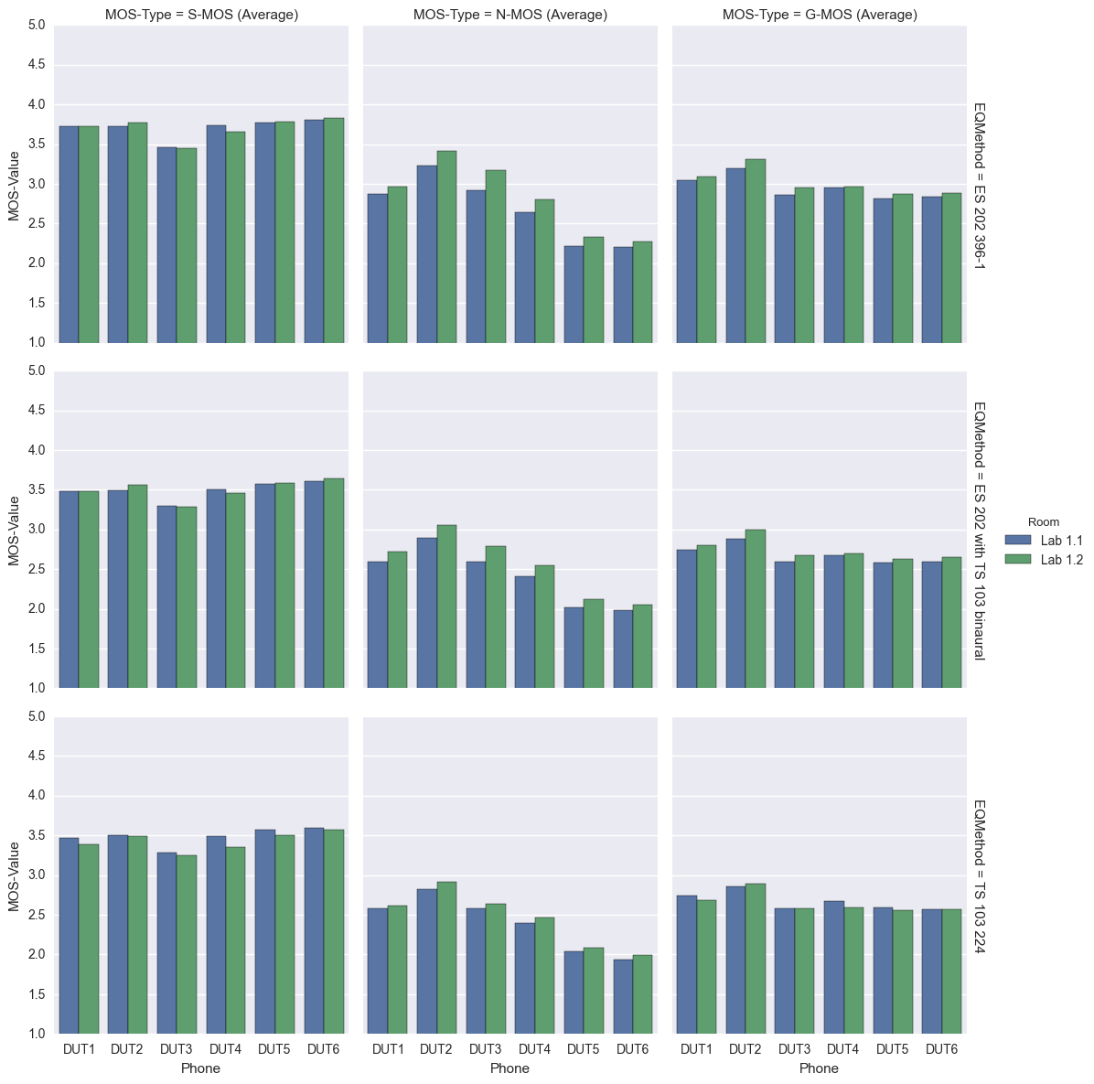

**Figure 14: Differences of MOS-values between method from TS 103 224 and method from ES 202 396-1 (HHHF, Wideband)**

**Differences between TS 103 224 and ES 202 396-1**

The following analyses were calculated by averaging the absolute values shown earlier and calculating the difference of the results for TS 103 224 and ES 202 396-1. The following observations can be made:

* The differences are quite big for all DUTs
* The values from TS 103 224 are consistently higher than from ES 202 396-1

**G-MOS**

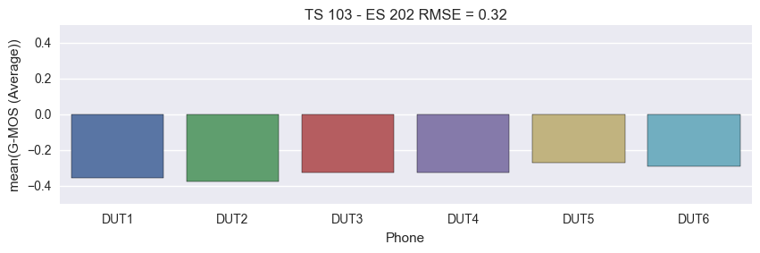

**S-MOS**

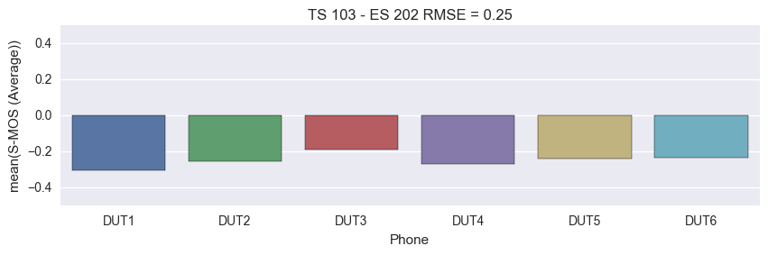

**N-MOS**

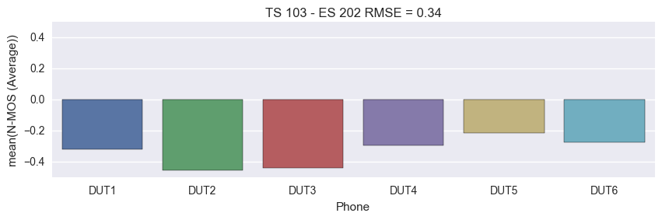

**Figure 15: Differences of MOS-values between method from TS 103 224 and method from ES 202 396-1 (HHHF, Wideband)**

**Differences between TS 103 224 and ES 202 396-1 with noises from TS 103 224**

The following analyses were calculated by averaging the absolute values shown earlier and calculating the difference of the results for TS 103 224 and ES 202 396-1 with noises from TS 103 224. The following observations can be made:

* The differences are smaller than in the previous case because noises were used which were recorded in the same situation
* The difference for every DUT is more similar to each other than in the previous case
* The values from TS 103 224 are consistently slightly higher than from ES 202 396-1

**G-MOS**

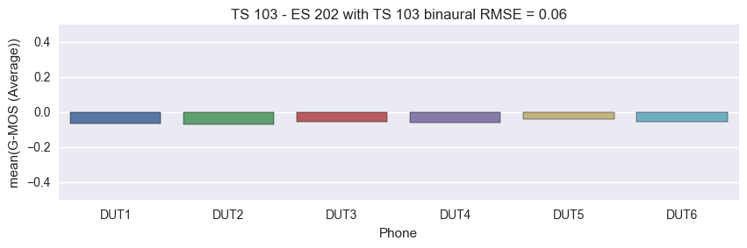

**S-MOS**

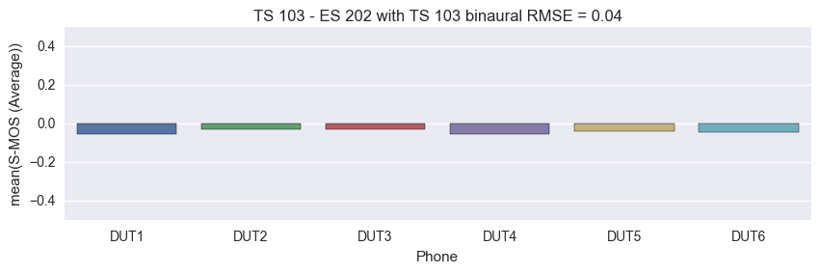

**N-MOS**

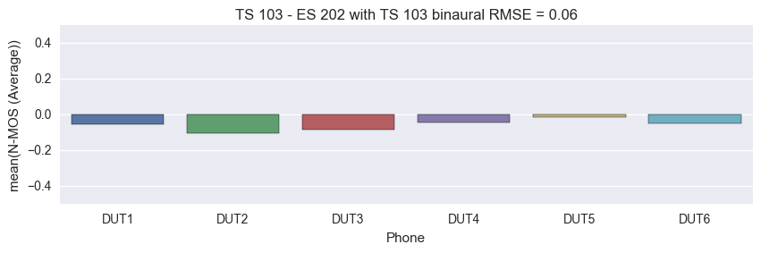

Figure 16: Differences of MOS-values between method from TS 103 224 and ES 202 396-1 with noises from TS 103 224 (HHHF, Wideband)

### Narrowband

**Absolute values**

This analysis shows the absolute MOS-values measured in the different rooms averaged over all background noises for every simulation method. The following observations can be made:

* S-MOS and N-MOS is always better in room 2

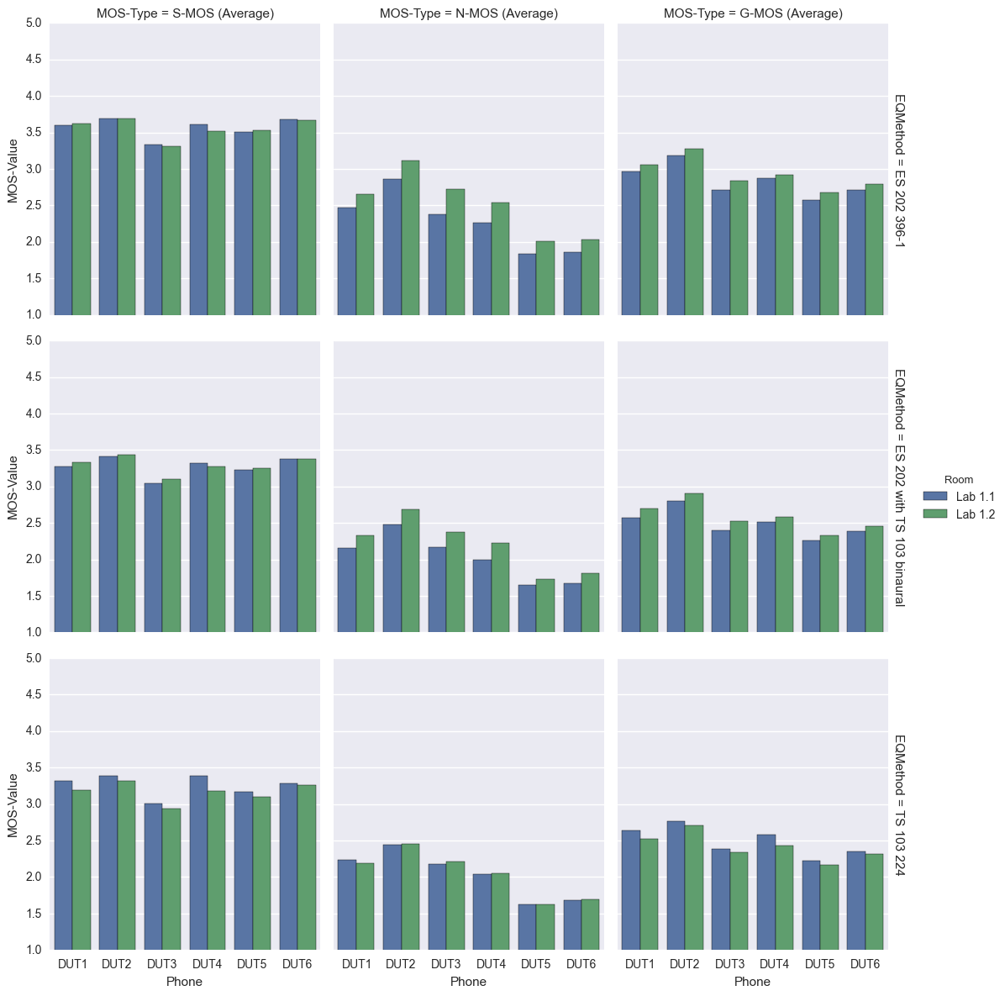 **Figure 17: Differences of MOS-values between method from TS 103 224 and method from ES 202 396-1 (HHHF, Narrowband)**

**Differences between TS 103 224 and ES 202 396-1**

The following analyses were calculated by averaging the absolute values shown earlier and calculating the difference of the results for TS 103 224 and ES 202 396-1. The following observations can be made:

* Quite large differences >0.5 can be observed
* The values from TS 103 224 are consistently higher than from ES 202 396-1

G-MOS

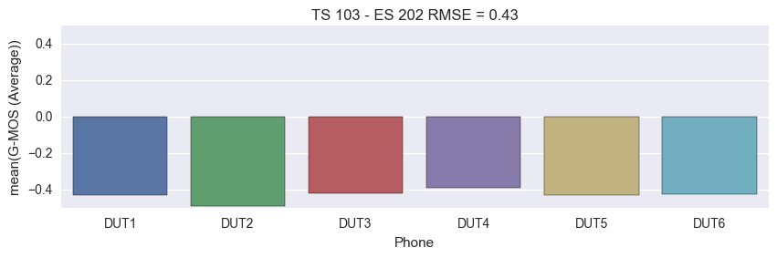

**S-MOS**

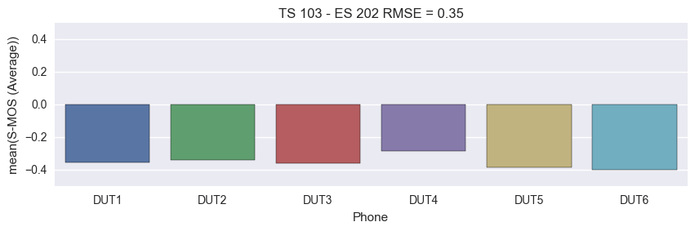

**N-MOS**

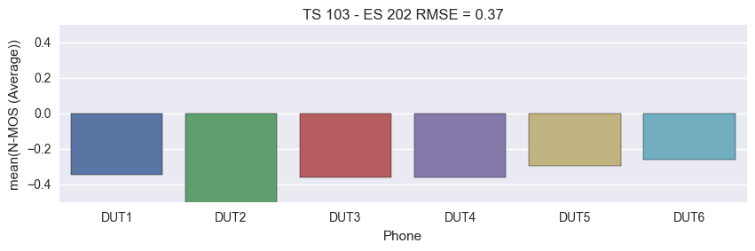

Figure 18: Differences of MOS-values between method from TS 103 224 and method from ES 202 396-1 (HHHF, Narrowband)

**Differences between TS 103 224 and ES 202 396-1 with noises from TS 103 224**

The following analyses were calculated by averaging the absolute values shown earlier and calculating the difference of the results for TS 103 224 and ES 202 396-1 with noises from TS 103 224. The following observations can be made:

* The differences are much lower than in the previous comparison because again noises were used which were recorded in the same situation
* The values from TS 103 224 are consistently slightly higher than from ES 202 396-1

**G-MOS**

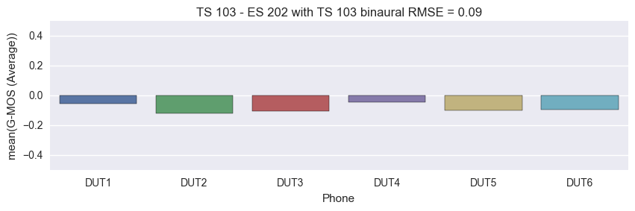

**S-MOS**

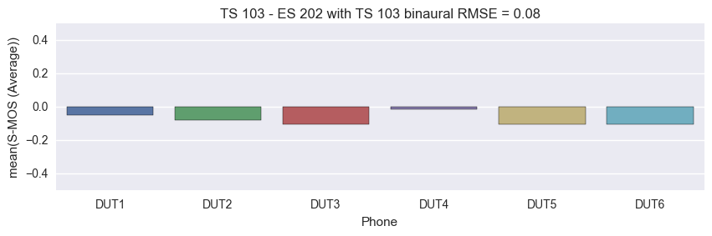

**N-MOS**

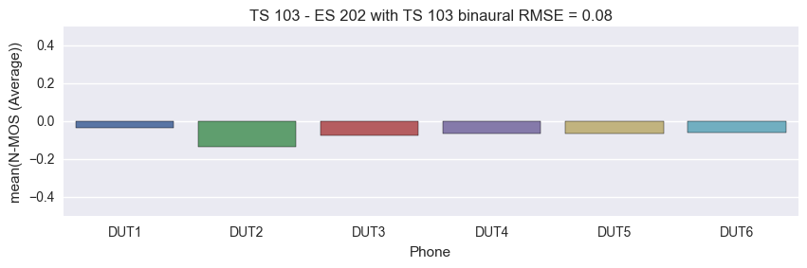

Figure 19: Differences of MOS-values between method from TS 103 224 and ES 202 396-1 with noises from TS 103 224 (HHHF, Narrowband)

## Analyses of the noise spectra reproduced at the reference microphone

The following two chapters show the noise spectra recorded at a reference microphone which was located close to the main microphone of the DUT. All available measurements for all 6 DUTs in both rooms are plotted into one diagram which means that one diagram contains 12 curves.

It can be seen that the differences in the case of the simulation acc. to ES 202 396-1 are quite big (about 7 dB) in contrast to the differences which can be observed for the simulation acc. to TS 103 224 (about 2 dB). This is the case for all background noises.

### Simulation & noises acc. to ES 202 396-1

**Cafeteria**



Figure 20: All spectra recorded at reference microphone for cafeteria noise with method from TS 103 224 in 1/3rd octave (HHHF)

**Crossroad**



Figure 21: All spectra recorded at reference microphone for cafeteria noise with method from TS 103 224 in 1/3rd octave (HHHF)

**Inside Car**



Figure 22: All spectra recorded at reference microphone for cafeteria noise with method from TS 103 224 in 1/3rd octave (HHHF)

**Office**



Figure 23: All spectra recorded at reference microphone for cafeteria noise with method from TS 103 224 in 1/3rd octave (HHHF)

**Pub**



Figure 24: All spectra recorded at reference microphone for cafeteria noise with method from TS 103 224 in 1/3rd octave (HHHF)

**Trainstation**



Figure 25: All spectra recorded at reference microphone for cafeteria noise with method from TS 103 224 in 1/3rd octave (HHHF)

### Simulation & noises acc. to TS 103 224

**Cafeteria**



Figure 26: All spectra recorded at reference microphone for cafeteria noise with method from TS 103 224 in 1/3rd octave (HHHF)

**Crossroad**



Figure 27: All spectra recorded at reference microphone for cafeteria noise with method from TS 103 224 in 1/3rd octave (HHHF)

**Inside Car**



Figure 28: All spectra recorded at reference microphone for cafeteria noise with method from TS 103 224 in 1/3rd octave (HHHF)

**Office**



Figure 29: All spectra recorded at reference microphone for cafeteria noise with method from TS 103 224 in 1/3rd octave (HHHF)

**Pub**



Figure 30: All spectra recorded at reference microphone for cafeteria noise with method from TS 103 224 in 1/3rd octave (HHHF)

**Trainstation**



Figure 31: All spectra recorded at reference microphone for cafeteria noise with method from TS 103 224 in 1/3rd octave (HHHF)

# Test results DTHF

## Comparison of Rooms

The following diagrams compare the MOS-values measured in the two different rooms by plotting the measured MOS-value of room 1 on the x-axis versus the measured MOS-value of room 2 on the y-axis. As the N-MOS value is the value which is mostly affected by different background noises most attention is paid to this value.

### Wideband

**No background noise**

The analysis without any background noise simulation present basically shows the variance to be expected between the different rooms.

The reasons for the differences were already described in 7.1.1.

**The RMSE ranges from 0.24 to 0.33. All MOS-results are slightly worse in room 2.**

|  |  |
| --- | --- |
|  |  |
|  | |

Figure 32: Correlation between MOS results from both rooms (DTHF, Wideband)

**Simulation acc. to ES 202 396-1 and noises from TS 103 224**

The results shown in this section are based on using the ES 202 396-1 Simulation but using the binaurally recorded background noises from TS 103 224. The following observations can be made:

* RMSE ranges from 0.06 to 0.17
* G-MOS results line up very well
* A slight offset can be observed for the S-MOS results
* N-MOS results are slightly scattered, resulting in an RMSE of 0.17

|  |  |
| --- | --- |
|  |  |
|  | |

Figure 33: Correlation between MOS results from both rooms (DTHF, Wideband)

**Simulation & noises acc. to TS 103 224**

The results shown in this section are based on using the TS 103 224 Simulation as well as the background noises from this standard. For this setup the following observations can be made:

* RMSE ranges from 0.05 to 0.10
* N-MOS results line up quite well in contrast to the method from ES 202 396-1 resulting in an RMSE of 0.09.

|  |  |
| --- | --- |
|  |  |
|  | |

Figure 34: Correlation between MOS results from both rooms (DTHF, Wideband)

### Narrowband

**No background noise**

The analysis without any background noise simulation present basically shows the variance to be expected between the different rooms.

The reasons for the differences were already described in 7.1.1.

**The RMSE ranges from 0.28 to 0.49. All MOS-results are slightly worse in room 2.**

|  |  |
| --- | --- |
|  |  |
|  | |

Figure 35: Correlation between MOS results from both rooms (DTHF, Narrowband)

**Simulation acc. to ES 202 396-1 and noises from TS 103 224**

The results shown in this section are based on using the ES 202 396-1 Simulation but using the binaurally recorded background noises from TS 103 224. The following observations can be made:

* RMSE ranges from 0.23 to 0.40
* Rather large offset for S-MOS.
* N-MOS scattered resulting in RMSE of 0.23.

|  |  |
| --- | --- |
|  |  |
|  | |

Figure 36: Correlation between MOS results from both rooms (DTHF, Narrowband)

**Simulation & noises acc. to TS 103 224**

The results shown in this section are based on using the TS 103 224 Simulation as well as the background noises from this standard. For this setup the following observations can be made:

* RMSE ranges from 0.16 to 0.42
* The N-MOS results line up pretty well in contrast to the method from ES 202-396-1.

|  |  |
| --- | --- |
|  |  |
|  | |

Figure 37: Correlation between MOS results from both rooms (DTHF, Narrowband)

## Comparison of equalization methods

### Wideband

**Absolute values**

The analysis shows the absolute MOS-values measured in the different rooms averaged over all background noises for every simulation method. The following observations can be made:

* G-MOS and S-MOS is always better in room 1
* N-MOS is mostly better in room 2

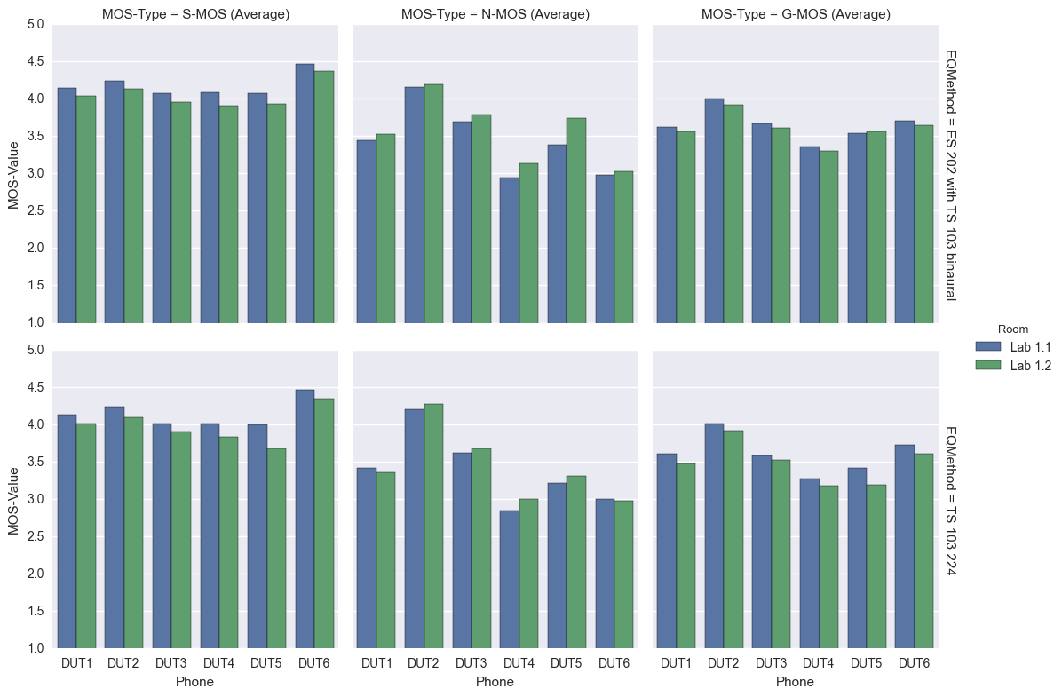

**Figure 38: Absolute MOS-values for both background noise simulations in both rooms averaged over all noises (DTHF, Wideband)**

**Differences between TS 103 224 and ES 202 396-1 with noises from TS 103 224**

In the following the absolute values for both rooms as shown above were averaged and the difference of the MOS-values between the two background noise simulation methods was calculated.

The largest difference can be observed for the N-MOS value. The reason for the differences between DUTs lies in the different signal processing algorithms used.

**G-MOS**

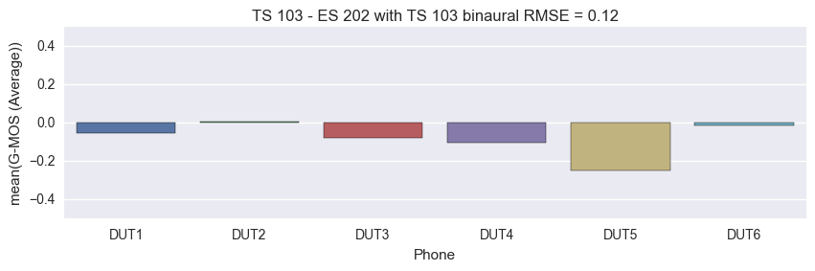

**S-MOS**

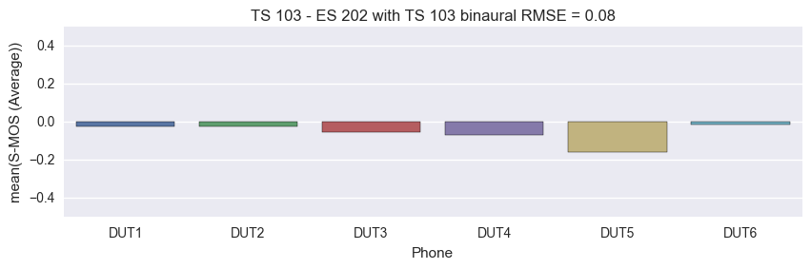

**N-MOS**

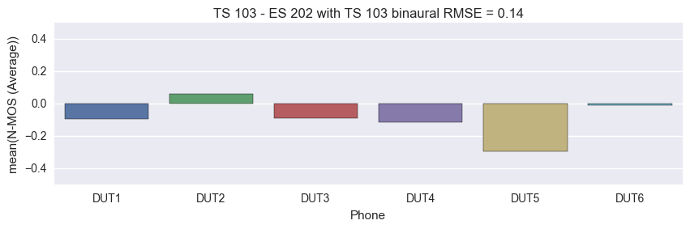

**Figure 39: Differences of MOS-values between method from TS 103 224 and method from ES 202 396-1 (DTHF, Wideband)**

### Narrowband

**Absolute values**

The analysis shows the absolute MOS-values measured in the different rooms averaged over all background noises for every simulation method. The following observations can be made:

* G-MOS and S-MOS is always higher in room 1
* N-MOS is always higher in room 2

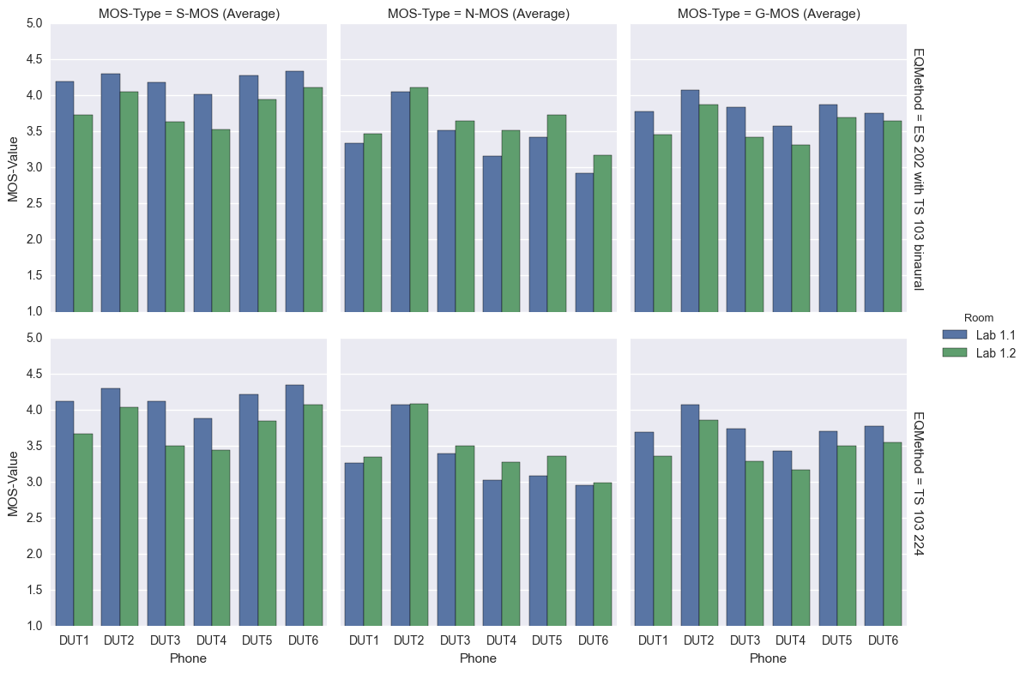 **Figure 40: Absolute MOS-values for both background noise simulations in both rooms averaged over all noises (DTHF, Narrowband)**

**Differences between TS 103 224 and ES 202 396-1 with noises from TS 103 224**

In the following the absolute values for both rooms as shown above were averaged and the difference of the MOS-values between the two background noise simulation methods was calculated.

The largest difference can be observed for the N-MOS value. The reason for the differences between DUTs lies in the different signal processing algorithms used.

**G-MOS**

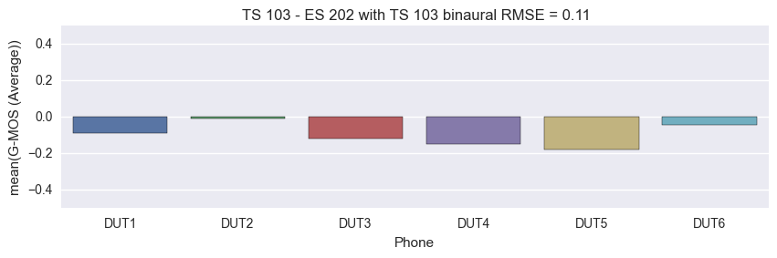

**S-MOS**

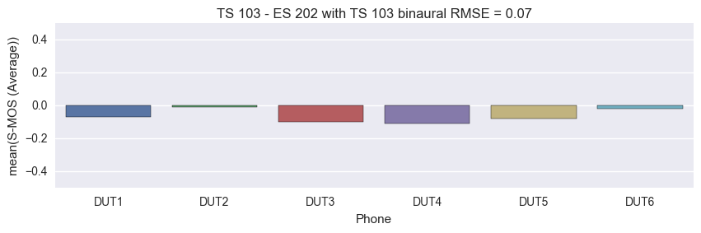

**N-MOS**

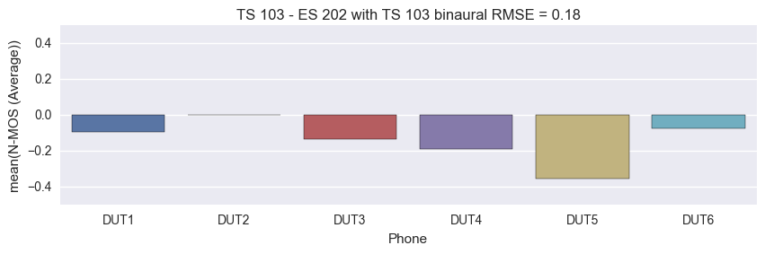

**Figure 41: Differences of MOS-values between method from TS 103 224 and method from ES 202 396-1 with noises from TS 103 224 (DTHF, Narrowband)**

## Analyses of the noise spectra reproduced at the reference microphone

The following two chapters show the noise spectra recorded at a reference microphone which was located close to the main microphone of the DUT. All available measurements for all 6 DUTs in both rooms are plotted into one diagram which means that one diagram contains 12 curves.

It can be seen that the differences in the case of the simulation acc. to ES 202 396-1 are quite big in contrast to the differences which can be observed for the simulation acc. to TS 103 224.

### Simulation acc. to ES 202 396-1



Figure 42: All spectra recorded at reference microphone for desktop office noise with method from ES 202 396-1 in 1/3rd octave (DTHF)

### Simulation acc. to TS 103 224



Figure 43: All spectra recorded at reference microphone for desktop office noise with method from TS 103 224 in 1/3rd octave (DTHF)

# Conclusions from the tests

The detailed conclusions about lab-to-lab variability is drawn in [6]. Some conclusions can be drawn from the results which were presented in this document:

* Good correlation with TS 103 224 although a reverberant room was compared with a ES 202 396-1 office type room.
* The noise spectra recorded with a reference microphone near the main microphone of the DUT are closest together with the method from TS 103 224.
* The correlation of the DTHF results in the case of ES 202 396-1 is quite good although the table is not equalized for.

# References

[1] Tdoc SQ-AHQ099, Proposed test plan for a Round Robin Test for comparison of background noise simulations – Rev. 1, Source: Editor (Qualcomm)

[2] S4-151040, ATeMPO_SPINE round-robin tests conducted at Sony, Source: Sony Mobile Communications

[3] Head Acoustics documentation provided for round robin

[4] ETSI ES 202 396-1, Speech quality performance in the presence of background noise; Part 1: Background noise simulation technique and background noise database

[5] ETSI TS 103 224, A sound field reproduction method for terminal testing including a background noise database

[6] Tdoc S4-xx, ATeMPO_SPINE Results of the Round Robin Test on Different Background Noise Simulation Techniques for Hand-Held Hands-Free Terminals